4TH INTERNATIONAL SYMPOSIUM ON ENHANCED LANDFILL MINING - PAPER TITLE
Jane SMITH¹, John SMITH², James SMITH^{1,2}
¹ Affiliation, Department, Postal code City, Country
² Affiliation, Department, Postal code City, Country
jane.smith@example.com, john.smith@example.com, james.smith@example.com

Introduction
Please use this template to make the editing of your paper (in UK English!) easier. Do not change font, font size, line spacing, paper size or margins to fit your text. These changes will be reversed once the correct template is applied. Use enters between paragraphs, not indents. Use the predefined heading and paragraph styles provided by this template. For more information about applying styles, see https://support.office.com/en-us/article/Apply-a-style-to-text-in-Word-f8b96097-4d25-4fac-8200-6139c8093109

Do not use extra enters before or after headings and lists, the correct spacing is implemented in the styles. The paper length for the (invited) Position papers is max. 14 pages, while the length for case-study Invited lectures is max. 6 pages. For all other papers (accepted as Oral Presentations, Pitch Presentations or Posters) the maximum length is 6 pages. Deadline for this paper Submission is November 10, 2017.

Title and paragraph styles
The font used is Calibri.

Table 1: Features of the predefined styles to be used in your paper
 | Font size  (pt) | Line Spacing  (pt) | Before  (pt) | After  (pt) | Extras
Paragraph | 12 | At least 16 | 0 | 0 | Justified
Title | 18 | At least 16 | 0 | 2 | Bold, uppercase
Heading 2 | 16 | At least 16 | 18 | 6 | Bold
Heading 3 | 13 | At least 16 | 12 | 3 | Bold
Heading 4 | 12 | At least 16 | 12 | 3 | Bold
Authors | 14 | At least 16 | 9 | 5 | Bold, last name uppercase
Affiliation | 11 | At least 14 | 0 | 0
Email | 12 | At least 16 | 6 | 6 | Italic
References | 10 | At least 13 | 0 | 0

Figures, tables & equations

Figures
Graphs can best be inserted as a picture by copying the picture from the program (excel, sigma-plot, matlab, …) and use ‘paste special’ as picture. If the graph is already in picture format, take care of the size of the picture and be aware that the A4 format will be reduced to a 16 cm by 24 cm format which is only 81% of A4. You can always check the outlook of your paper by zooming in to 81%. 300 dpi is in most cases big enough. A higher size can make the document too heavy.

Figure 1: Centre your figures and captions. Captions are placed underneath the figure and the name of the figure is written in bold. Make sure your figures are still clear when printed in grayscale. Remove any border around your figures.

If more figures are put next to each other a table can be used and the pictures can be put in the table as shown below. Remove any table borders after placing the figures.

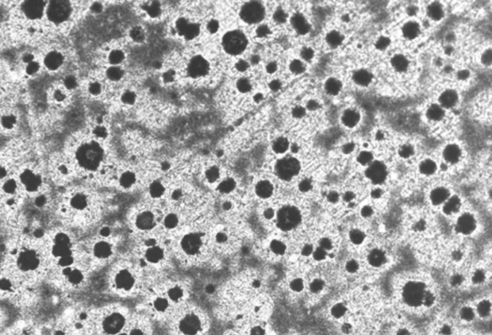  a) |  | 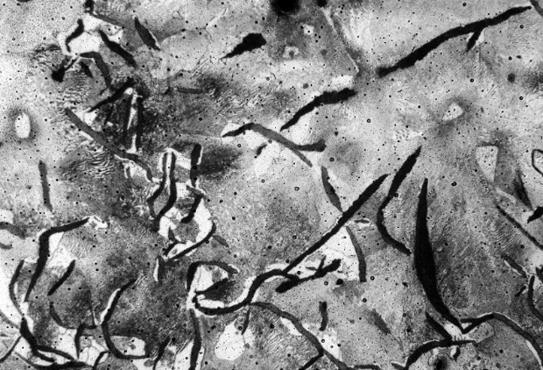  b)
Figure 2: Two figures next to each other, with a) one figure and b) a second figure

Tables
Insert your tables as Word or Excel tables. Use the same font size as the paragraph text and do not use bold in the table. Centre the text in the table, apart from the left column.

Table 2: Centre your tables and table captions. Captions for tables go above the table and the table name is written in bold.
Sample nr | Property 1 | Property 2 | Property 3 | Property 4
1 | 3.4 | 2.5 | 1.6 | 4.8
2 | 5.5 | 14.8 | 5 | 3
3 | 5.9 | 9.1 | 1.2 | 7

Equations
Equations are numbered with brackets. Their number is outlined to the right. You can use a right tab as in Equation (1) or a table, as shown in Equation (2).

G(p,T) = U + pV - TS (1)

(2)

Special characters
Insert specials characters in the text as symbols, rather than using Equation tools or similar software. Some commonly used special characters are °, α, β, δ, γ, λ, ϒ, μ, θ, Δ, Λ, Σ, ±, ≤, ≥.

References
References are indicated in the text by a number in superscript¹. Do not use automatic numbering². Some examples of references³ are given below. Journal titles are italic and abbreviated and volumes are bold.

- D. Durinck, G. Mertens, P. T. Jones, J. Elsen, B. Blanpain and P. Wollants, “Slag Solidification Modeling Using the Scheil-Gulliver Assumptions”, J Am Ceram Soc, 90 (4) 1177-85 (2007).
- S. Arnout, M. Guo, D. Durinck, P. T. Jones, J. Elsen, B. Blanpain and P. Wollants, “Phase Relations in Stainless Steel Slags”, in Proceeding of European Metallurgical Conference (EMC 2007), Edited by N. L. Piret. Society for Mining, Metallurgy, Resources and Environmental Technology (GDMB), Düsseldorf, Germany, 2007.
- H.A. van der Sloot, L. Heasman, P. Quevauviller, Harmonization of leaching/extraction tests, Elsevier, Amsterdam, 1997.

